MANDATORY DISCLOSURE (as on 10.05.2022 )

1 | AICTE File No | Permanent Id: 1-2486967171  Application Id: 1-9318611809
 | Date & Period of Last Approval | 25-June-2021
2 | Name of the Institution | GOVERNMENT COLLEGE OF ENGINEERING
 | Address of the Institution | Gandharvakottai Road, Sengipatti, Thanjavur– 613 402.
 | State | Tamil Nadu
 | Phone Number with STD Code | 04362 – 221112
 | Fax Number with STD Code | -
 | Office hours at the Institution | 09.45 AM – 5.45 PM
 | Academic hours at the Institution | 9.00 AM – 4.50 PM
 | E – mail | gcesengipatti@gmail.com
 | Website | www.gcetj.edu.in
 | Nearest Railway Station | THANJAVUR JUNCTION (27 kms)
 | Nearest Airport | TRICHY AIRPORT (39 kms)
3 | Type of Institution | Government
 | Category (1) of the Institution | Non-Minority
 | Category (2) of the Institution | Co – Education
4 | Name of the affiliating University | Anna University Chennai
 | Address | Sardar Patel Road, Guindy, Chennai – 600 025
 | Website | www.annauniv.edu
 | Latest affiliation period | 2020 – 21
5 | Name of Principal | Dr. M.NATARAJ
 | Exact Designation | Professor & Principal
 | Phone number with STD Code | 04362 – 221113
 | FAX number with STD Code | -
 | Email | principal@gcetj.edu.in
 | Highest Degree | Ph.D.
 | Field of Specialization | Mechanical Engineering

ORGANISING CHART
P.A. to
Principal
Physical
Education Director
Librarian
Teaching
Faculties
Hostel
Management
Technical
Supporting Staffs
Safety&
Security
Office Staff
Bursar
Prof. & HoD’s
Academic
Administrative
Principal
Director of Technical Education

- GOVERNING COUNCIL

Name | Position | Qualification | Present Designation/ Occupation | Telephone Numbers | Mobile No. | E-mail id | Address
Dr.A.ELAYAPERUMAL | Members | Ph.D.-Mechanical Engineering | Associate Professor | 0431 -  22357646 | 9443210281 | ep_mal@yahoo.com | Centre of Affiliation of Institutions, Anna University ,  Chennai- 25
Mrs. CHANDRA SENA BALA | Members | B.E.- Electronics and Communication Engineering | General Manager | - | 9440000613 | Gmttnj_tn@bsnl.co.in | Principal Quarters, GCE Campus Srirangam - Trichy 620012  Thiruchirappalli
Dr.S. JAYANTHI | Members | Ph.D.-Civil Engineering | Professor | 0427 -  2346157 | 9894055758 | Sjai63@gmail.com | Principal GCE Salem  636011  Salem
Dr.M. NATARAJ | Member Secretary | Ph.D.-Mechanical Engineering | Principal | 04362-  221112 | 9894516524 | gcesengipatti@gmai l.com | Principal quarter GCEcampus Sengipatti-Thanjavur613402 Thanjavur
Mrs. V.SAKUNDALA | Members | Ph.D.-  Mechanical Engineering | General Manager | - | 9443029486 | tnjdic@gmail.com | District Industries Center - Thanjavur Thanjavur
Mr.BASKARAN T | Chairman | B.E.-Mechanical Engineering | General Manager | - | 9442631217 | bossbaskarant@gmail.com | GM quarters BHEL - Tiruchirappalli-14 Thiruchirappalli

- PLANNING AND MONITORING COMMITTE

Name | Position | Category | Qualification | Present Designation  / Occupation | Mobile | E mail | Address
Dr.M.NATARAJ | Chairman | Principal of the college | Ph.D. -  Mechanical Engineering | Principal | 9894516524 | gcesengipatti@gmail.com | Principal Quarters GCE Campus-Sengipatti, Thanjavur 613402
Mr. K.KARTHIKEYAN | Member | Industrial expert in the field of engineering | B.E. - Mechanical Engineering | Industrialist | 9842909713 | shanenggindus@gmail.com | M/s Velmurugan Heavy Industries pvt.Ltd Sengipatti, Thanjavur - 613 402 Thanjavur
Mrs. I.MUTHUMANI | Member | Senior faculty member of the college | M.E. - Computer Science and Engineering | Professor | 9942177861 | muthumanisubash@yahoo.co.in | 20 ,First Floor , Subhiksha Towers 6th Street- Subramaniyapuram North Ext. Karaikudi 630002 Sivagangai
Mrs. S.A.T. SHANMUGAPRIYA | Member | Senior faculty member of the college | M.Sc.M.Phil. -Chemistry | Associate Professor | 9443365385 | satshanmugapriya@gmail.com | 214 / B Kumaran Street,  7 th Cross Pari Nagar- Karaikudi,630003,Sivagangai
Dr.S JAYABAL | Member | Senior faculty member of the college | Ph.D. - MechanicalEngineering | Professor | 9842909713 | jayabalsubbaiyan@gmail.com | Government College of Engineering, Gandharvakottairoad, Sengipatti, Thanjavur
Mr. R.VIGNESHKUMAR | Member | Industrial expert in the field of engineering and technology | B.E. - Mechanical Engineering | Industrialist | 9597613956 | venkatsasdhabhel@gmail.com | M/s. Goldcup Aerated Works-Thanjavur, Thanjavur
Mr. C. SENTHIL | Member | Architect /Civil Engineer | B.E. - Electrical and Electronics Engineering | Engineer | 9655248291 | tech.edu@gmail.com | Technical Education,  Thanjavur.

- ANTI – RAGGING COMMITTEE

S.No | Name | Position | Present Designation / Occupation | Mobile
1 | Dr. NATARAJ M | Chairman | Principal | 9894516524
2 | Dr.S.SUMATHI | Member | Associate Warden | 9080889135
3 | Mr.R.SASIKUMAR | Member | Sub Inspector of Police, Sengipatti | 9498134857
4 | Mr.R.SIVA KUMAR | Member | Tahsildar, Budalur | 9943961046
5 | Mr.P.S.THIRUMARAN | Member | District Chair Person, Lion Club, Thanjavur | 9865133371
6 | Mr.G.VIJAYAKUMARAN | Member | PA to Principal | 9894383533
7 | Mrs.M.RAJAPPA | Member | Parent / R.Lokatharani (I Year Civil) | 9884234876
8 | Mr.A.VIJAYAN | Member | Student / IV Year Mechanical | 9976273394

- ANTI RAGGING SQUAD

Name | Position | Present Designation  /Occupation | Mobile Numbers | E- mail | Address
Dr. NATARAJAN M | Chairman | Principal | 9894516524 | gcesengipatti@gmail.com | Principal Quarters GCE - Campus-Thanjavur-613402
Dr. SUMATHI S | Member | Associate Warden | 9865193599 | sumathigce@gmail.com | 8 New Housing UnitThanjavur-613005
Dr. S.JAYABAL | Member | HOD / Mech. | 9842909713 | jayabalsubbaian@gmail.com | 9 SV BhavanKollapuram- Thiruvarur,609608
Dr. P.KRISHNAMOORTHY | Member | Faculty Member | 9688335083 | krishandkrish@yahoo.com | B2/18 Nalli Highways Apartment-Old Pal Pannai Trichy-620008 Thiruchirappalli
Dr. MANIKANDAN R | Member | Faculty Member | 9943658161 | kmk_manoj@yahoo.com | 56, Agragaram,Kollidam, Nagapattinam – 609 102.
Mrs. RENUGA DEVI K | Member | Faculty Member | 7904572661 | renu.sks90@gmail.com | Muthulakshmi Apartment, Near Balaji Weight Machines Sengipatti-613402, Thanjavur
Mrs.S.A.T.SHANMUGAPRIYA | Member | Associate Professor / Chief faculty Advisor (S&H) | 9443365385 | satshanmugapriya@gmail.com | 214/B Kumanan Street 7th Cross Pari Nagar-Karaikudi 630003  Sivagangai
Mr.G.VIJAYAKUMARAN | Member | PA to Principal | 9894383533 | gandhivijayakumaran@gmail.com | 2-20, Gandhi Street, KeelakalkandarkottaiTrichy  620 011

- DISCIPLINE AND WELFARE COMMITTEE

S.No. | Name | Position | Category | Mobile | E mail | Address
1 | Dr. NATARAJAN M | Chairman | Principal | 9894516524 | gcesengipatti@gmail.com | Principal Quarters GCE - Campus-Thanjavur-613402
2 | Dr. JAYABAL .S | Member | Senior Faculty Member | 9842909713 | jayabalsubbaian@gmail.com | Government College of Engineering, Sengipatti.-Thanjavur-613402
3 | Mr. ARUNKUMAR.M | Member | Student Counselor (Staff) | 9943080391 | marumkumar@gcetj.edu.in | Government College of Engineering, Sengipatti.-Thanjavur-613402
4 | Mrs. AARTHY.E | Member | Student Counselor (Staff) | 9698970406 | eaarthy@gcetj.edu.in | Government College of Engineering, Sengipatti.-Thanjavur-613402
5 | Mrs. INDRA.G | Member | Warden / Deputy Warden of Girls Hostel | 9884960811 | indra@gcetj.edu.in | Government College of Engineering, Sengipatti.-Thanjavur-613402
6 | Mr.MANOJKUMAR.K | Member | Warden / Deputy Warden of Boys Hostel | 9994873594 | kmk_manoj@yahoo.com | 56 Agraharam-SirkaliTk Kollidam-609102

- COMPLAINTS CUM REDRESSAL COMMITTEE

S.No | Name | Category | Present Designation  /Occupation | Mobile | E mail | Address
1 | Dr. NATARAJAN M | Chairman | Principal | 9894516524 | gcesengipatti@gmail.com | Principal Quarters GCE - Campus-Thanjavur-613402
2 | Dr. JAYABAL S | Professor | Professor | 9842909713 | jayabalsubbaian@gmail.com | Principal Quarters GCE Campus-Thanjavur-613402 Thanjavur
3 | Mr. NACHIAPPAN RM | Member | Associate Professor | 9384102600 | dcenachiappan@gmail.com | 93/98 S P Koil Street- Chidambaram,608001 Cuddalore
4 | Dr. MAHALAKSHMI C | Member | Associate Professor | 9047297197 | maha_2008@yahoo.com | S4 ShakthiRagav Residency, 6 Kamala Avenue,Thanjavur-613 005
5 | Dr. SUGUNA N | Member | Associate Professor | 9500400345 | sssugana@yahoo.co.in | 21/8 5 thCross,SundharamNagar,Mangalapuram-Thanjavur 613004
6 | Dr. SUBRAMANIAM K | Ombudsman | Retired Professor | 9486634911 | subramaniamk@gmail.com | GCE SRIRANGAM-TRICHY,620012

- SC / ST COMMITTEE

S.No | Name | Position | Present Designation  / Occupation | Mobile | E- mail
1 | Dr.S.JAYABAL | Chairman | Vice Principal | 9842909713 | jayabalsubbaian@gmail.com
2 | Mr.R.RAMJI | Member | Assistant Professor / ECE | 9123540329 | ramjir@gcetj.edu.in
3 | Mrs.S.A.T.SHANMUGAPRIYA | Member | Associate Professor / Chemistry | 9443365385 | satshanmugapriya@gmail.com
4 | Dr. S.SUMATHI | Member | Assistant Professor (Sr.Gr) / Civil | 9865193599 | sumathigce@gmail.com
5 | Dr. SIVASANKAR.S | Member | Assistant Professor / Mech. | 8248924421 | shivasankar09@gmail.com
6 | Mr.T.MURUGAN | Member | FOREMAN INSTRUCTOR | 6382890860 | murugant@gcetj.edu.in
7 | Mrs.C.SUSILA | Member | SUPERITENDENT | 8883026892 | susilac@gcetj.edu.in

- SEXUAL HARASSMENT COMMITTEE

S.No | Name | Position | Present Designation  / Occupation | Mobile | E- mail
1 | Dr. NATARAJAN M | Chairman | Principal | 9894516524 | gcesengipatti@gmail.com
2 | Dr.S.JAYABAL | Member | Professor / Mech. | 9842909713 | jayabalsubbaian@gmail.com
3 | Mrs.S.A.T.SHANMUGAPRIYA | Member | Associate Professor / Chemistry | 9443365385 | satshanmugapriya@gmail.com
4 | Dr. S.SUMATHI | Member | Assistant Professor (Sr.Gr) / Civil | 9865193599 | sumathigce@gmail.com
5 | Mr.M.ANBALAGAN | Member | Chairman of TIME Organisation, Womans Development and Empowerment, Budalur, Thanjavur | 9443797410 | timechandra@gmail.com

- STUDENT GRIEVANCE AND REDRESAL COMMITTEE

S.No | Name | Position | Present Designation  / Occupation | Mobile | E- mail | Address
1 | Dr. T.RAMESH | Ombudsman | Associate Professor | 9994339803 | tramesh@nitt.edu | National Institute of Technology, Trichy.
2 | Dr. NATARAJAN M | Chairman | Principal | 9894516524 | gcesengipatti@gmail.com | Principal Quarters GCE - Campus-Thanjavur-613402
3 | Dr.R.MANIKANDAN | Member | Associate Professor / CSE | 9994125244 | rmkmanikandan@yahoo.co.in | 1/64 Koviloor Post, Alangudi TK, Cuddalore
4 | Dr.C.MAHALAKSHMI | Member | Associate Professor / EEE | 9047297197 | maha_C2008@yahoo.com | S4,Sakthi Rakav Residency, Kamala Avanue, Thanjavur – 613 005
5 | Dr.M.THAMBIDURAI | Member | Assistant Professor / Mech. | 9585088222 | thambidu@gmail.com | D3 New Kothangudi Flats, Annamalainagar, Chidambaram, Cuddalore
6 | Mr.P.L.SENTHILKUMAR | Member | Assistant Professor / Civil | 9790121611 | toopls@gmail.com | 30/27 Gandhi Nagar, Chidambaram – 608 001 Cuddalore.
7 | Mr.A.DINESH | Member | Assistant Professor / ECE | 9894173017 | dineshcolours@gmail.com | 28/36 Sivan West Street, Nagoor – 611002 ,Nagapattinam.
8 | Mrs.A.NIRMALA | Member | Assistant Professor / Maths | 9578143991 | nirmalamaths.try@gmail.com | 5 Rajanagar, BikshandarKoil, No1 Tool Gate, Trichy – 621216.

STUDENT FEEDBACK MECHANISM ON INSTITUTIONAL GOVERNANCE/ FACULTYPERFORMANCE

  - At the end of every semester, faculty teaching performance is being evaluated through feedback forms by students for all the subjects and follow up action will betaken

  - During class committee meetings and at the time of students counseling, Students evaluate Institutional Governance.

GRIEVANCE REDRESSAL MECHANISM FOR FACULTY, STAFFAND STUDENTS

- HODMeetings

- DepartmentMeetings

- Retest are conducted for thestudents

- Studentscounseling

PROGRAMMES

- NAME OF THE PROGRAMMES APPROVED BYAICTE

S.No | Department | Name of the Programme | Duration | Approved Student Intake | Year of Starting
1 | Civil Engineering | B.E. Civil Engineering | 4 Years | 60 | 2013
2 | Mechanical Engineering | B.E. Mechanical Engineering | 4 Years | 60 | 2013
3 | Electrical & Electronics Engineering | B.E. Electrical & Electronics Engineering | 4 Years | 60 | 2013
4 | Electronics & Communication Engineering | B.E. Electronics & Communication Engineering | 4 Years | 60 | 2013
5 | Computer Science & Engineering | B.E. Computer Science & Engineering | 4 Years | 60 | 2013

- NUMBER OF STUDENTS ADMITTED IN LAST THREEYEARS

S.No | Department | 2019 - 20 | 2020 -21 | 2021 - 22
1 | Civil Engineering | 46 | 55 | 47
2 | Mechanical Engineering | 56 | 52 | 45
3 | Electrical & Electronics Engineering | 50 | 45 | 48
4 | Electronics & Communication Engineering | 54 | 46 | 47
5 | Computer Science & Engineering | 54 | 50 | 48
Total |  | 260 | 248 | 235

CUT OFF MARKS
- ACADEMIC YEAR – 2021 – 2022

Department |  | CSE | ECE | EEE | MECH | CIVIL
Cut off Marks
OC | Max | 188 | 181.34 | 176.15 | 179 | -
 | Min | 166.75 | 180.65 | - | - | -
BC | Max | 187.3 | 185.69 | 181.5 | 177.67 | 173.3
 | Min | 123 | 169.67 | 161.07 | 158.24 | 156.065
BCM | Max | 186.22 | 172 | 156.57 | 163.175 | 154.3
 | Min | 171.55 | 152.99 | 155.81 | 160.475 | 145.2
MBC | Max | 189.5 | 181.51 | 175.65 | 176.15 | 173.36
 | Min | 165.38 | 170.935 | 165.49 | 158.56 | 158.39
SC | Max | 180.715 | 171.03 | 174.045 | 179.57 | 178.56
 | Min | 147.56 | 167.265 | 165 | 160.1 | 160
SCA | Max | 171.9 | 165.33 | 154.81 | 164.46 | 137.85
 | Min | 143.615 | 161 | 138 | 145.9 | -
ST | Max | - | - | - | - | -
 | Min | - | - | - | - | -

- ACADEMIC YEAR – 2020 - 2021

Department |  | CSE | ECE | EEE | MECH | CIVIL
Cut off Marks
OC | Max | 175.5 | 183 | 156.5 | 143 | 147.5
 | Min | 147 | 131.5 | 109 | 88 | 80
BC | Max | 147.5 | 155 | 96.5 | 120.5 | 104
 | Min | 136.5 | 123 | - | 82.5 | -
BCM | Max | 161 | 165 | 138 | 124 | 142.5
 | Min | 140.5 | 124.5 | 112.5 | 96 | 89
MBC | Max | 172 | 120.5 | 126 | 139 | 134
 | Min | 92.5 | 117.5 | 107.5 | 90 | 80
SC | Max | - | - | - | - | -
 | Min | - | - | - | - | -
SCA | Max | - | - | - | - | -
 | Min | - | - | - | - | -
ST | Max | 175.5 | 183 | 156.5 | 143 | 147.5
 | Min | 147 | 131.5 | 109 | 88 | 80

- ACADEMIC YEAR – 2019 - 2020

Department |  | CSE | ECE | EEE | MECH | CIVIL
Cut off Marks
OC | Max | - | 151.5 | - | - | -
 | Min | - | - | - | - | -
BC | Max | 172.5 | 165 | 160 | 173 | 147.5
 | Min | 80 | 131 | 111 | 115.5 | 105.5
BCM | Max | 159 | 149 | 117.5 | 141.5 | -
 | Min | 138.5 | 104 | - | 104 | -
MBC | Max | 164.5 | 162 | 170 | 129.5 | 149.5
 | Min | 144 | 137.5 | 116 | 115 | 109
SC | Max | 159.5 | 138.5 | 151 | 134 | 128.5
 | Min | 121.5 | 118.5 | 114 | 103 | 97.75
SCA | Max | 113 | - | 92.5 | 102 | 130
 | Min | 107.5 | - | - | - | -
ST | Max | - | - | - | 112 | -
 | Min | - | - | - | - | -

DETAILS OF FACULTY MEMBERS
Department Of Mechanical Engineering

S.No | Name | Designation | Mobile | E- mail
1 | Dr.S .JAYABAL | Professor & Head | 9842909713 | jayabalsubbaian@rediffmail.com
2 | Dr.T.RADHIKA | Assistant Professor | 9943658161 | kt.radhika@gmail.com
3 | Dr.S.SIVASANKAR | Assistant Professor | 8248924421 | shivasankar09@gmail.com
4 | Mr.V.GURUKARTHIKEYAN | Assistant Professor | 8122077083 | gurumech37@gmail.com
5 | Dr.R.VELAPPAN | Assistant Professor | 8489832201 | velrama_2006@yahoo.co.in
6 | Dr.M.THAMBIDURAI | Assistant Professor | 9585088222 | tambidu@gmail.com
7 | Dr.R.M.NACHIAPPAN | Associate Professor | 9384102600 | dcenachiappan@gmail.com
8 | Dr. B.ASAITHAMBI | Assistant Professor | 9486959384 | asaithambi100@yahoo.com
9 | Dr.V.SUBRAVEL | Assistant Professor | 9940062272 | subra.vetri@gmail.com
10 | Dr.B.CHANDRAMOHAN | Assistant Professor | 9842429992 | chandramohanb@gcetj.edu.in
11 | Mr.K.SENTHILKUMAR | Assistant Professor / (ADHOC) | 8344518235 | senthil30may@gmail.com

Department of Electronics & Communication Engineering

S.No | Name | Designation | Mobile | E- mail
1 | Mr. R.RAMJI | Assistant Professor/ HoD (i/c) | 9123540329 | janramji@gmail.com
2 | Mr. K.MANIKANDAN | Assistant Professor | 7708455046 | kmanikandan028@gmail.com
3 | Mrs. K. RENUKA DEVI | Assistant Professor | 9751684207 | renu.sks90@gmail.com
4 | Dr. A.ASOKAN | Associate Professor | 7904195872 | asokan2k7@gmail.com
5 | Mr. A.DINESH | Assistant Professor | 9894173017 | dineshcolours@gmail.com
6 | Mr. G.R.ANUSHA KUMAR | Assistant Professor | 9894161288 | anush765@gmail.com
7 | Mr. M.SELVAKUMAR M | Assistant Professor | 7010358122 | ms.lecturer@gmail.com
8 | Mr. S. MOHAN | Assistant Professor | 9789548001 | mohann85@yhaoo.co.in
9 | Mr. D. BALAKUMAR | Assistant Professor | 9994820353 | dbalakumarr@gmail.com
10 | Mr. S. KULOTHUNGAN | Assistant Professor | 9842008333 | kulothungann@gmail.com

Department of Electrical and Electronics Engineering

S.No | Name | Designation | Mobile | E- mail
1 | Dr. P.KRISHNAMOORTHY | Assistant Professor & Head (i/c) | 9688335083 | krishnandkrish@yahoo.com
2 | Mr. K.S.GOWTHAMAN | Assistant Professor | 8870720537 | ksgowthaman1989@gmail.com
3 | Mr. M.ARUNKUMAR | Assistant Professor | 9943080391 | arunkumarmurugesan88@gmail.com
4 | Mrs. S.SUBALAKSHMI | Assistant Professor | 9994486131 | subhas_sujas@yahoo.co.in
5 | Dr. C.MAHALAKSHMI | Associate Professor | 9047297197 | maha_c2008@yahoo.com
6 | Dr. R. BALAMURUGAN | Associate Professor | 9865067560 | bala_aucdm@yahoo.com
7 | Dr. P.S.PRAKASH | Assistant Professor | 9865274443 | prakashaueee@gmail.com
8 | Dr. R. ANANDAKUMAR | Assistant Professor | 9842565052 | anand_r1979@yahoo.com
9 | Dr. S.RAJASOMASEKAR | Assistant Professor | 9345510460 | rajasomashekar@yahoo.in
10 | Dr. M.KALPANA DEVI | Assistant Professor | 9786090873 | sharikka09@yahoo.com
11 | Mr. M. SIVASUBRAMANI | Assistant Professor / (ADHOC) | 9944575643 | pgpshiva@gmail.com

Department of Civil Engineering

S.No | Name | Designation | Mobile | E- mail
1 | Dr. S.SUMATHI | Assistant Professor (Sr.Gr) & Head (i/c) | 9865193599 | sumathigce@gmail.com
2 | Mrs. V.RAMYA | Assistant Professor | 9488385707 | ramyajoolie@gmail.com
3 | Mr. R.VIVEKANANDAN | Assistant Professor | 7010089961 | rvivekanandan.vivek4@gmail.com
4 | Ms. E.AARTHY | Assistant Professor | 9698970406 | aarthy006t@gmail.com
5 | Mr. T.KAVIMANI | Associate Professor | 9994229546 | tkavimani@gmail.com
6 | Mr. S.SELVAMUTHUKUMAR | Assistant Professor | 9443527191 | ssnk_civil@rediffmail.com
7 | Mr. P.L.SENTHIL KUMAR | Assistant Professor | 9790121611 | toopls@gmail.com
8 | Dr. ILANGO SIVAKUMAR | Assistant Professor | 9486072989 | isk_kpm@yahoo.com
9 | Mr. K. SIVAKUMAR | Assistant Professor [ADHOC] | 8526157203 | sivakumar23494@gmail.com
10 | Mrs.P. EPSHEELA SHEELARANI | Assistant Professor [ADHOC] | 8012412599 | epsheelap@gmail.com

Department of Computer science & Engineering

S.No | Name | Designation | Mobile | E- mail
1 | Mr. K.MANOJKUMAR | Assistant Professor & Head (i/c) | 9942179861 | kmk_manoj@yahoo.com
2 | Dr. G.MAHALAKSHMI | Assistant Professor | 9629371185 | gmahalakshmi@gces.edu.in
3 | Mr. N.KARTHIKEYAN | Assistant Professor | 6369528007 | karthi796@gmail.com
4 | Dr. G.INDIRANI | Associate Professor | 9486869926 | indiranig@gcetj.edu.in
5 | Dr. N.SUGUNA | Associate Professor | 9500400345 | sssuguna@yahoo.co.in
6 | Dr. R.MANIKANDAN | Associate Professor | 9994125244 | rmkmanikandan@yahoo.co.uk
7 | Dr. G. PATTABIRANI | Assistant Professor | 9629502344 | prvijayaraja@gmail.com
8 | Dr. K.SANTHOSH KUMAR | Assistant Professor | - | santhoshkumark@gcetj.edu.in
9 | Mr. G. TAMILKUMARAN | Assistant Professor [ADHOC] | 9994392172 | tamilkumaran.g@gmail.com
10 | Ms. V. VIJAYA BHARATHI | Assistant Professor [ADHOC] | 9788627804 | vijayabharathi16@yahoo.com
11 | Ms. K. VINOTHINI | Assistant Professor [ADHOC] | 8056604363 | ka.vinodhini@gmail.com
12 | Ms. A.NOORUL RISHWANA BEGUM | Assistant Professor [ADHOC] | 8940780470 | rishwana29@gmail.com

Science and Humanities

S.No | Name | Designation | Mobile | E- mail
DEPARTMENT OF CHEMISTRY
1 | Mrs. S.A.T.SHANMUGA PRIYA | Associate Professor /Chief Faculty Advisor | 9443365385 | satshanmugapriya@gmail.com
2 | Dr. N.SURESH BABU | Assistant Professor | 9994396411 | babusuresh1982@gmail.com
3 | Dr. K.KALAIMATHI | Assistant Professor | 9585799657 | kalaielan81@gmail.com
4 | Dr. M.L.SUNDARARAJAN | Assistant Professor | 9842172050 | ml.sundararajan_assistprof@rediffmail.com
DEPARTMENT OF PHYSICS
1 | Mrs. R.SWARNA LAKSHMI | Assistant Professor | 9715691107 | swarna.physics@gmail.com
2 | Mr. J.AYYAPPAN | Assistant Professor | 8892719887 | ayyappanphysics@gmail.com
3 | Mrs. G.INDIRA | Assistant Professor | 9884960811 | indira@gcetj.edu.in
4 | Dr. P.SARITHA | Assistant Professor | 9443884504 | psarithaau@yahoo.com
DEPARTMENT OF MATHAMATICS
1 | Ms. K.VIDYA | Assistant Professor | 9994839169 | vidya1089@gmail.com
2 | Mr. V.SENTHIL | Assistant Professor | 9943805027 | senthilpriyan2017@gmail.com
3 | Mrs. R.UMA | Assistant Professor | 8675942177 | umaramachandran26@gmail.com
4 | Mrs. A.NIRMALA | Assistant Professor | 9578143991 | nirmalamaths.try@gmail.com
5 | Mr. R. JEGANATH | Assistant Professor [ADHOC] | 8973065554 | jeganmaths@gmail.com
DEPARTMENT OF ENGLISH
1 | Ms. A.RAJAMANI | Assistant Professor | 8675846040 | rajamani9428@gmail.com
2 | Mr. M.TAMILSELVAN | Assistant Professor | 8056367378 | tamilsir1985@gmail.com
3 | Mr. S.POOSAIMANI | Assistant Professor | 9788598560 | poosaimani1982@gmail.com

HEAD OF THE INSTITUTION

Name of Head of the Institution: Dr. M.NATARAJ |  | 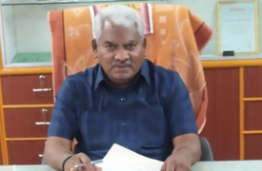
Designation | PRINCIPAL
Date of Joining the Institution | 30/12/2021
Qualification | UG | PG |  | Ph.D.
 | B.E. – Mechanical Engineering | M.E. – CAD/CAM |  | Mechanical Engineering
Total Experience in Years | Teaching | Research |  | Industry
 | 36 Y | 20 |  | -
Projects Guided | UG | PG |  | Ph.D
 | 84 | 36 |  | 10
Papers published | National |  | International
 | 12 |  | 53

DETAILS OF TEACHING FACULTY MEMBERS

S.No | Department | Available Staff Members
1 | Civil Engineering | 10
2 | Mechanical Engineering | 11
3 | Electrical & Electronics Engineering | 11
4 | Electronics & Communication Engineering | 10
5 | Computer Science & Engineering | 12
6 | Science and Humanities & General Engineering | 16
Total (Except Principal, Physical director&  Librarian) |  | 70

FEESTRUCTURE

- One – Time fee to be collected duringadmission

1 | Admission fee | 200
2 | AU Registration fee | 1200
3 | Medical Insurance | 200
4 | Syllabus Fee | 200
5 | HSC certificate verification fee* | 50
6 | DOTE certificate verification fee | 15
7 | NSS Membership, | 10

- Refundable Deposits (One Time – At the time ofAdmission)

8 | a. Institution Deposit | 500
9 | b. Library Deposit | 500

- Fees to be collected per annum

10 | Tuition fee ** | 2000
11 | Development Charges | 1000
12 | Special fees | 1500
13 | Library fee | 100
14 | Computer charges | 1250
15 | Sports fee | 200
16 | Other Fees | 505
Total fees to be paid |  | 9430

* FeeException for Direct Second year
** Tuition Fee Exception for SC/ST students, Physically Challenged Students etc.,
INFRASTRUCTURALINFORMATION

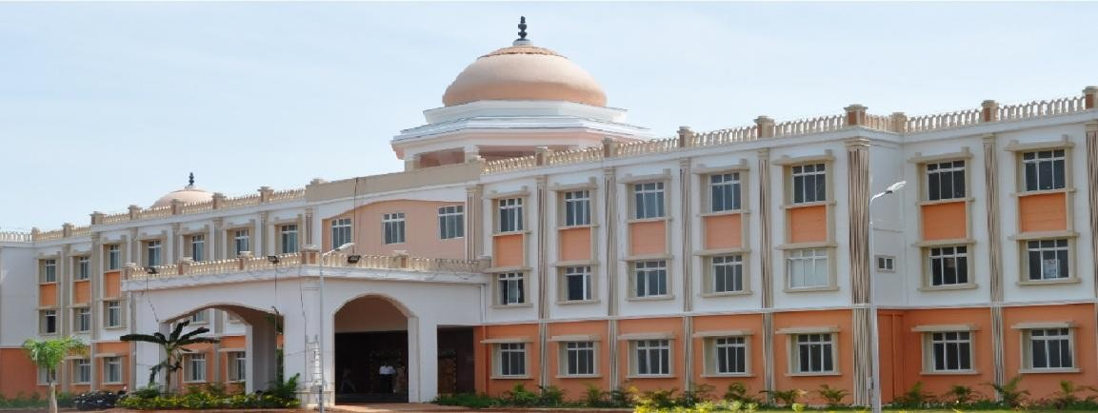
- AdministrativeBuilding

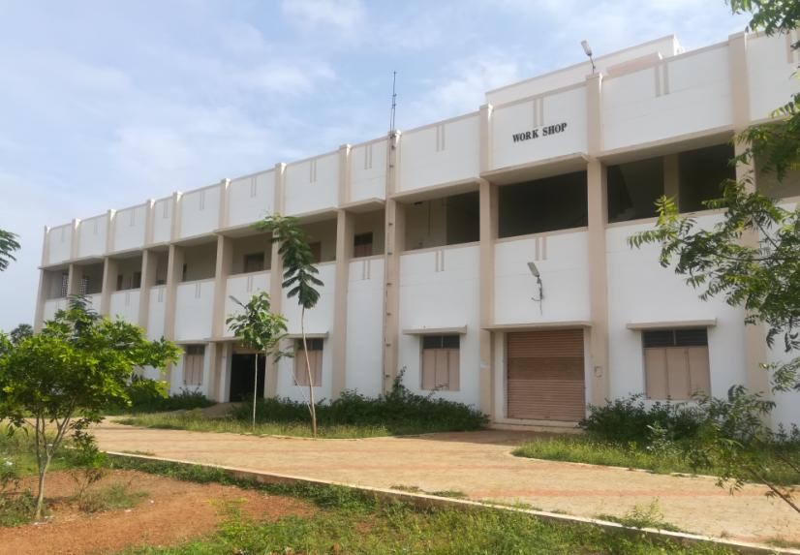
- Laboratories /Workshops

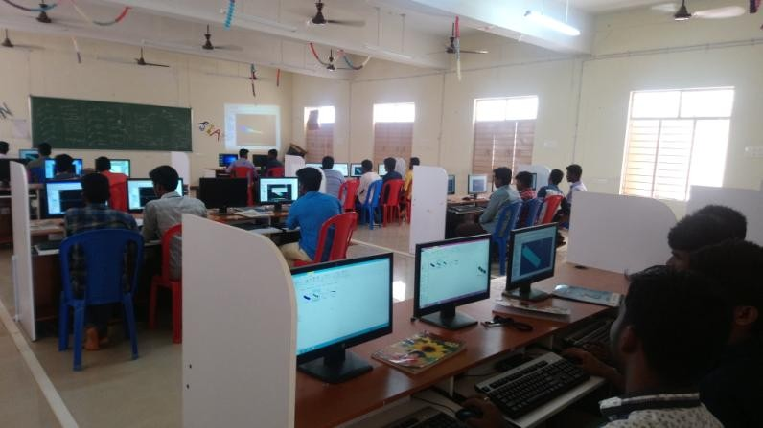
- ComputerCenters

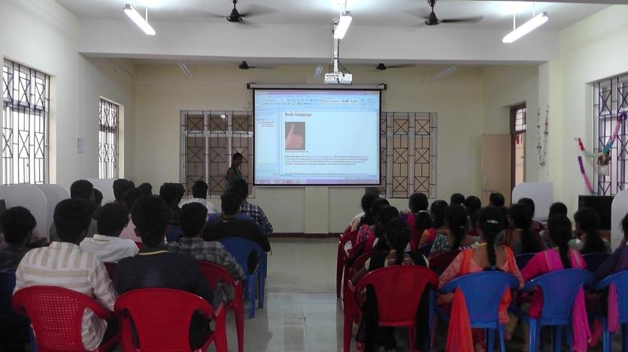
- Language Laboratory

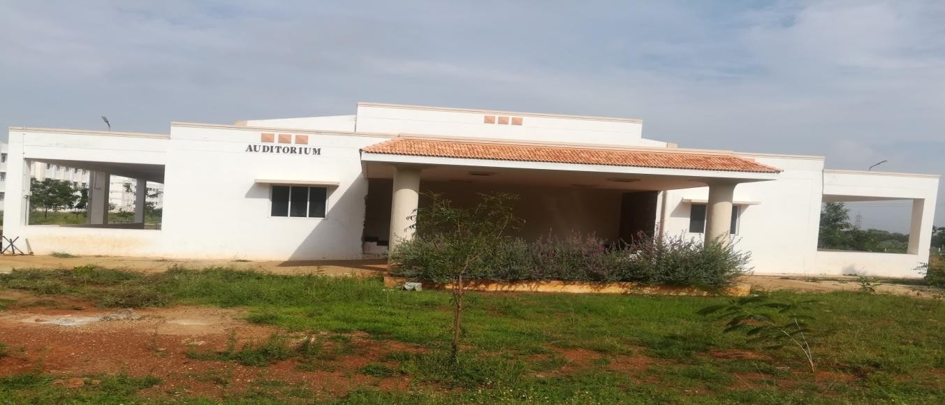
- Auditorium

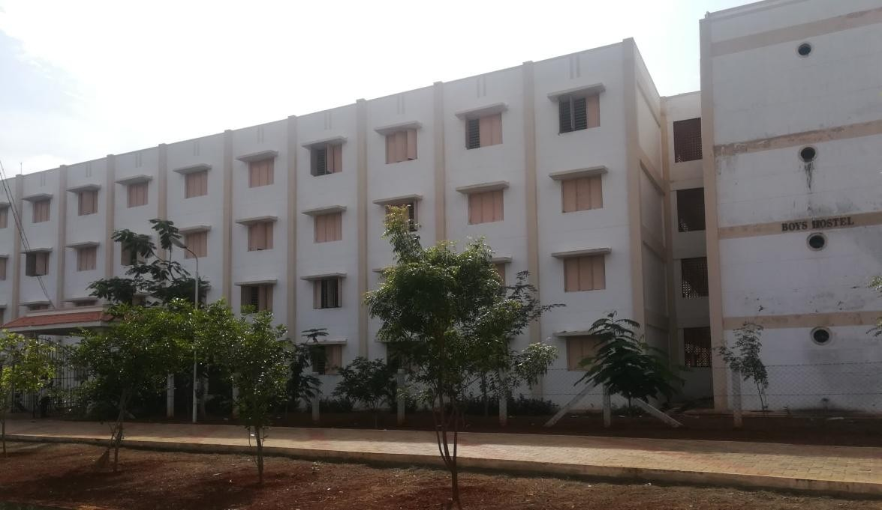
- BoysHostel

- Girls Hostel
